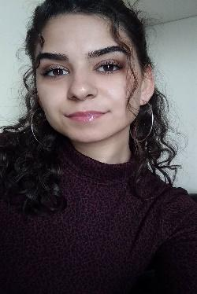

**Team Name**: Omedi

**Team Members:** Dilan Kaya & Osman Melih Tolunay

**Main Contact fort the Instructor:** Dilan Kaya

**TEAM INFORMATIONS:**

* **Dilan Kaya**

1. Mail: [dilankayaa16@gmail.com](mailto:dilankayaa16@gmail.com)
2. Phone Number: 05536817398
3. I'm available at any time during the day for response.

**Biography:**

Dilan Kaya, I was born on 15th March 1998 in Antalya. I went to primary school in Hüseyin Avni Çöllü and high school in Serik Atatürk Anatolian High School. I had an accident in 2014 and I gave a break to my education for a year and graduated from Private Maarif Anatolian High School. I won Adnan Menderes University, but I studied at Akdeniz University for two years due to a special situation. I came to Adnan Menderes University in 2019 and continue my education. I started programming when I won the university.

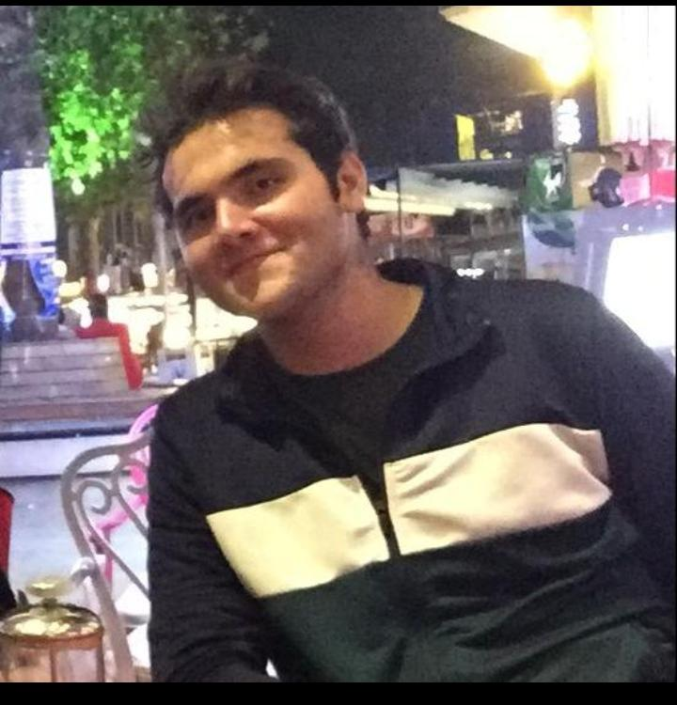

* **Osman Melih Tolunay**

1. Mail: [omelihtolunay@gmail.com](mailto:omelihtolunay@gmail.com)
2. Phone Number:05432898092
3. I'm available at any time during the day for response

**Biography:**

Osman Melih Tolunay, I was born on 4th August 1999 in Burdur.

Till high school graduation I had been living in Burdur Bucak. When I

was 10 -12 years old I started to make some bots for RPG games and

this is how I started programming. After that I started to make some UI

designs with some script languages. When I was 17 years old I started

studying about Linux, cyber security and ethical hacking. For 2 years

(beginning of university) I am working on NLP and Linguistics so, I have

been studying on some computer systems for a long time. Also, I worked

in some freelancer jobs and some companies in different positions.

1. We do our meeting on the Zoom.
2. We set the time to meet during the day. We decided to continue the meeting one day apart. [This is an image from our meeting](../Desktop/Firstvirtualmeeting.png)
3. We will use version Control 1 File is already uploaded to Github. After 2nd control.
4. Dilan will take care of the management and planning part, and Melih will take care of the software and the nlp part. Both sides should help each other when necessary.
5. Melih and Dilan will deliver this part on November 5th.
6. In case of emergency, the team member who cannot catch up with the job will show the initiative and complete the deficiencies.
7. Github : <https://github.com/dilankya/omedi>
8. Here our team Picture:

